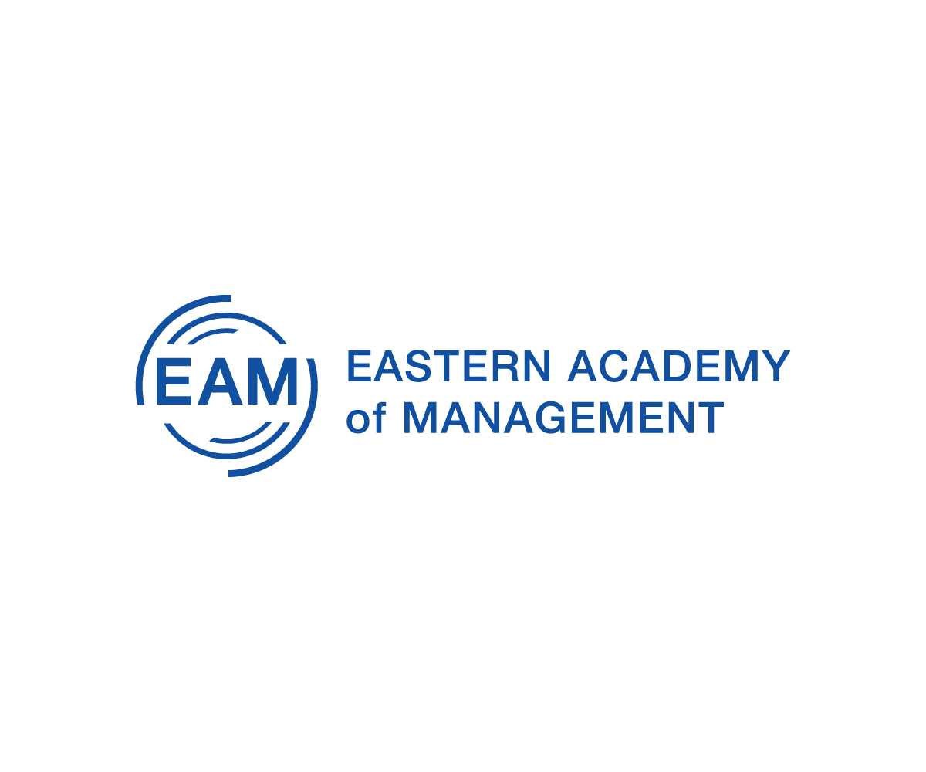

**59th ANNUAL MEETING**

**May** **17** **–** **20,** **2022** **|** **Portland, Maine**

**The Westin Harborview**

**www.eaom.org**

Racial injustice, a global pandemic, and political unrest. These are just a few of the myriad of world-wide events that have challenged individuals, businesses, and organizations during the past few years. They have led to what have been often dramatic changes coupled with financial pressures in our lives and our workplaces. Many individuals have had to work remotely while juggling family responsibilities. Many organizations had had to change how work is performed while they attempted to fulfill their missions and keep their staff safe. Entire industries such as hospitality and entertainment were shut down for extended periods, and academia was forced to look in the mirror and ask itself some hard questions. During the past few years, we have been tested in ways we never imagined. Yet we persisted, and we continue to persist. We have been resilient, and we look forward to the future, but do so with the realization that things have changed. So, let us reflect on the past as we consider the future and ask ourselves: What have we learned from the past few years? How will we as individuals and organizations use this new knowledge? What specifically can leaders do to help us move forward? How can we adapt as the rate of change keeps increasing? What role will technology play in this ever-changing landscape? What do businesses need from us as researchers? What does this mean for how and what we teach? What new skills should we be imparting on our students? Eastern Academy of Management will explore these and other questions.

**Conference** **Theme:**

**Resilience and Reinvention: Moving Forward**

Life can only be understood backwards, but it must be lived forwards.”

Søren Kierkegaard

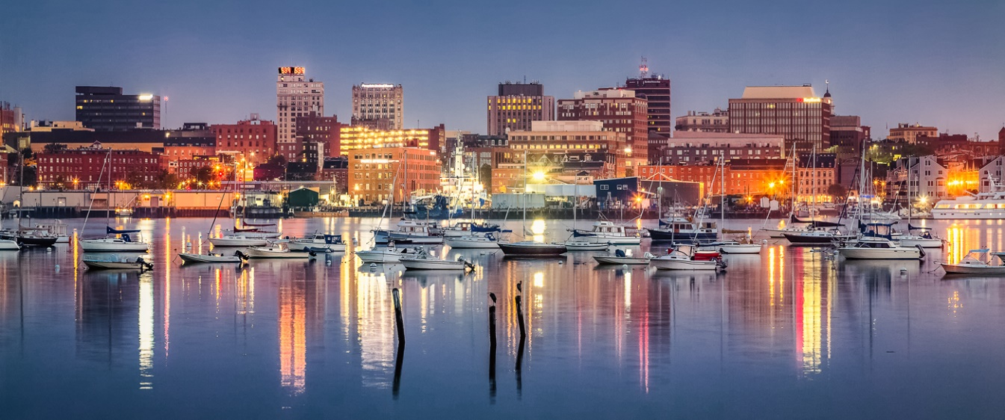

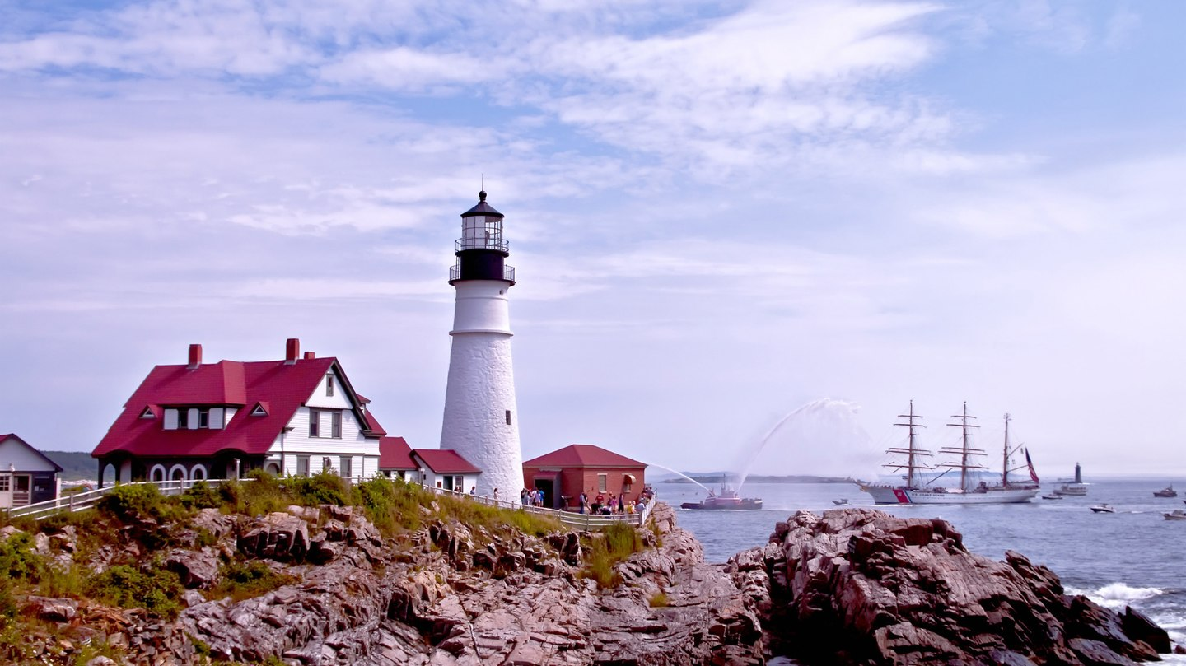

Join us in downtown historic art district of Portland, a short walk to the Old Port and some of the best restaurants, retail shops, museums and artistic venues in Maine. Each of the guest rooms features a stunning view of downtown, the harbor or Casco Bay. Situated adjacent to Interstate 95, two hours north of Boston and four hours from Hartford, Portland is convenient to get to for travelers coming from the north or the south. The Portland International Jetport (PWM), just 3 miles from downtown, offers nonstop flights to over a dozen cities across the U.S. and Canada as well as worldwide connections.

EAM is a learning community of college educators and scholars devoted to members’ professional development as well as the advancement of management theory, research, education, and practice. Affiliated with the Academy of Management, we augment and complement AOM's activities by conducting our own domestic and international meetings.